**6. Half Wave Rectifier**

**Introduction**

When the diode is employed in rectification process, it is referred to as rectifier. Here we are expanding our discussion to include time varying functions such as sine wave and square wave.

* + We are going to assume an ideal diode in which diode forward voltage drops are neglected
  + Vi :Input voltage
  + V0 :Output voltage
  + Mark polarities of
    1. Source voltage
    2. Diode voltage drop
    3. Output voltage

**Circuit Diagram**

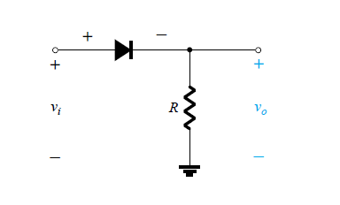

Fig 6.1

**Input voltage waveform**

* + 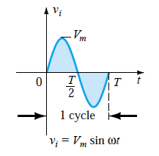Time period =T
  + Average value = 0

Fig 6.2

**Working principle**

|  |  |  |
| --- | --- | --- |
|  | + ve Half Cycle | -ve Half Cycle |
| Time | 0<t<T/2 | T/2<t<T |
| Source voltage polarity | + ve | -ve |
| Circuit  Diagram | During the interval 0<t<T/2,the polarity of the applied voltage vi is such as to establish “pressure” in the direction indicated and turn on the diode with the polarity appearing above the diode | For the period T/2 → T, the polarity of the input vi is as shown . |
| Modified  Circuit  Diagram  (Diode as a closed switch) | Substituting the short-circuit equivalence for  the ideal diode will result in the equivalent circuit . where it is fairly obvious that the output signal is an exact replica of the applied signal. The two terminals defining the output voltage are connected directly to the applied signal via the  short-circuit equivalence of the diode. | the resulting polarity across the ideal diode produces an “off” state with an open-circuit  equivalent. The result is the absence of a path for charge to flow and vo=iR= (0)R = 0 V for the period T/2 → T. |
| Output Voltage  waveform |  |  |
| Output Voltage | Same as source voltage | zero |

**Input & output waveform**

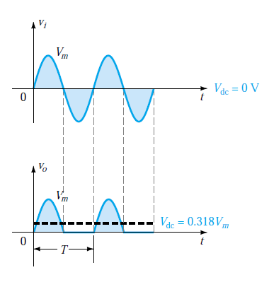

Fig 6.3

**Calculating Vdc( for Ideal diode)**

* + The output signal v0now has a net positive area above the axis over a full period and an average value determined by
* V**dc=**0.318Vm
  + The process of removing one-half the input signal to establish a dc level is called half-wave rectification*.*

**Calculating Vdc (for non-Ideal diode)**

* The effect of using a silicon diode with VT=0.7 V is demonstrated in Fig 6.4 for the forward-bias region.
* The applied signal must now be at least 0.7 V before the diode can turn “on.”
* For levels of vi< 0.7 V, the diode is still in an open circuit state and v0 =0 V as shown in the same figure.
* When conducting, the difference between vo and viis a fixed level of VT = 0.7 V and vo= vi - VT*,* as shown in the Fig 6.4.
* The net effect is a reduction in area above the axis, which naturally reduces the resulting dc voltage level.
* For situations where Vm>>VT, Eq. below can be applied to determine the average value with a relatively high level of accuracy.
* Vdc = 0.318(Vm -VT)

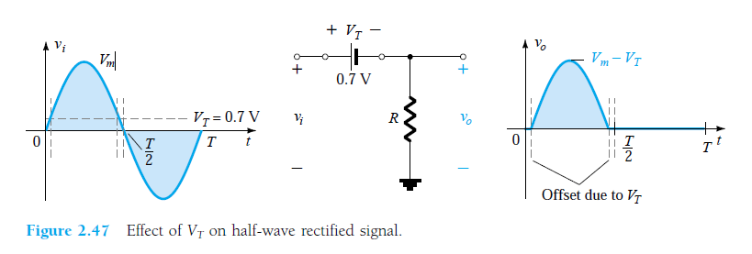

Fig 6.4

**PIV**

* + PIV – peak inverse voltage
  + Aka PRV – peak reverse voltage
  + Very important in the design of rectifier system
  + Def – ‘ it is the voltage rating that must not be exceeded in the reverse-bias region or the diode will enter the Zener avalanche region.’
  + It displays the reverse-biased diode with maximum applied voltage.
  + Applying Kirchhoff”s voltage law, it is fairly obvious that the PIV rating of the diode must equal or exceed the peak value of the applied voltage. Therefore,

PIV should be ≥ Vm for half wave rectifier

**Circuit Diagram**

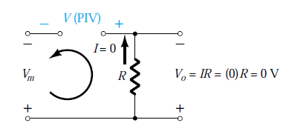

Fig 6.5

**Disadvantage**

* The DC level obtained is less and this can be improved to 100% using a process called full wave rectification.

**7. Full Wave Rectifier**

**Input Voltage**

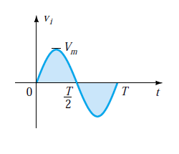

Fig 7.1

**Circuit Diagram**

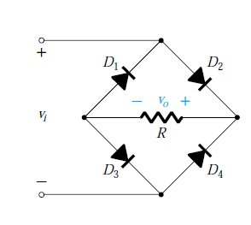

Fig 7.2

**Working principle:**

|  |  |  |
| --- | --- | --- |
|  | + ve Half Cycle | -ve Half Cycle |
| Time | 0<t<T/2 | T/2<t<T |
| Source voltage |  |  |
| Source voltage polarity | + ve | -ve |
| Circuit  Diagram |  |  |
| Modified  Circuit  Diagram  (Diode as a closed switch) |  |  |
| Output Voltage  waveform |  |  |
| Output Voltage | Same as source voltage | - (source voltage) |

**Input & Output voltage waveform:**

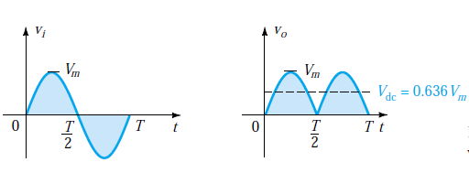

1. **PIV**
   * Peak inverse voltage = Vm
2. **Calculating Vdc( for Ideal diode)**
   * Since the area above the axis for one full cycle is now twice that obtained for a half-wave system, the dc level has also been doubled.

Vdc (full wave rectifier)= 2× Vdc (half wave rectifier)

Vdc = 2(0.318Vm)

Vdc = 0.636Vm

1. **Calculating Vdc( for practical diode)**
   * If silicon rather than ideal diodes are employed as shown in Figure below

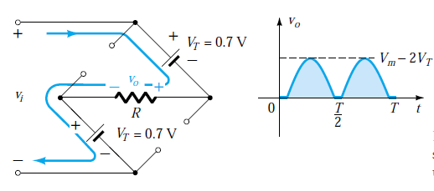

Fig 7.3

* + Applying Kirchhoff’s voltage law we get
    1. vi - VT - vo-VT=0
    2. vo= vi- 2VT
  + The peak value of the output voltage vois therefore
    1. Vomax= Vm-2VT
  + For situations where Vm>>2VT*,* the below equation can be applied for the average value with a relatively high level of accuracy.
    1. Vdc= 0.636(Vm- 2VT)

**Example Problems**

1. **Half Wave Rectifier Circuit- with I-V characteristics**

* Complexity Level : NORMAL
* Textbook Name : Electronic Devices and circuit Theory, 7th Edition, PHI
* Author Name : Robert Boylestad
* Page Number : 103 (Tutorial Problem)Qn. 1

(a) Using the characteristics of Fig. b, determine ID, VD, and VRfor the circuit of Fig.a.

(b) Repeat part (a) using the approximate model for the diode and compare results.

(c) Repeat part (a) using the ideal model for the diode and compare results.



**SOLUTION:**

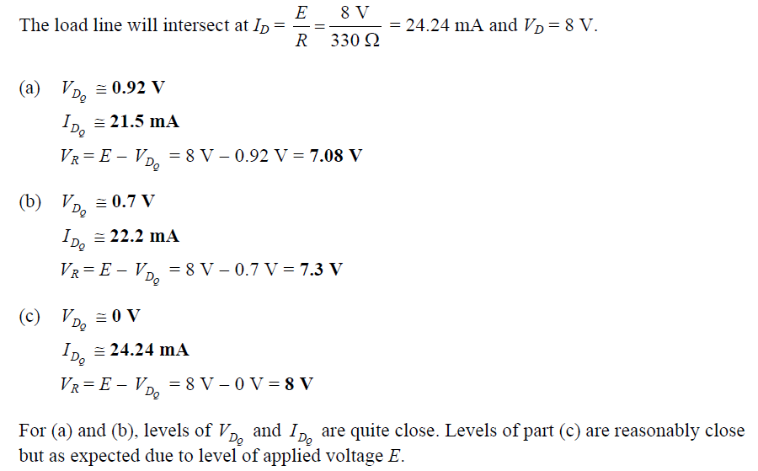

1. **Half Wave Rectifier Circuit- with I-V characteristics**

* Complexity Level : NORMAL
* Textbook Name : Electronic Devices and circuit Theory, 7th Edition, PHI
* Author Name : Robert Boylestad
* Page Number : 103 (Tutorial Problem)Qn. 2

(a) Using the characteristics of Fig. below, determine ID and VDfor the circuit of Fig. below

(b) Repeat part (a) with *R* =0.47k.

(c) Repeat part (a) with *R* =0.18 k

(d) Is the level of VDrelatively close to 0.7 V in each case?

How do the resulting levels of ID compare? Comment accordingly.



**SOLUTION:**

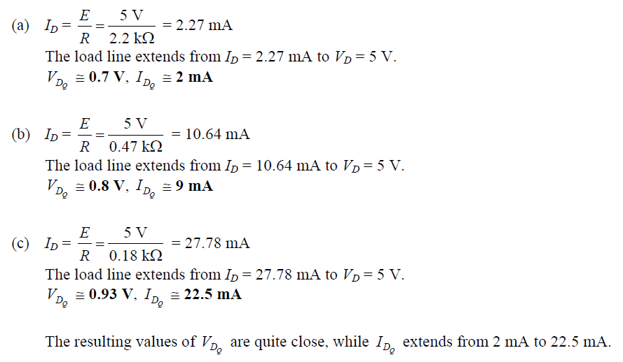

1. **Half Wave Rectifier Circuit :( Resistance Calculation)**

* Complexity Level : NORMAL
* Textbook Name : Electronic Devices and circuit Theory, 7th Edition, PHI
* Author Name : Robert Boylestad
* Page Number : 103 (Tutorial Problem)Qn.3

Determine the value of *R* for the circuit of Fig. below that will result in a diode current of 10 mA if *E* = 7 V. Use the characteristics of Fig below for the diode.

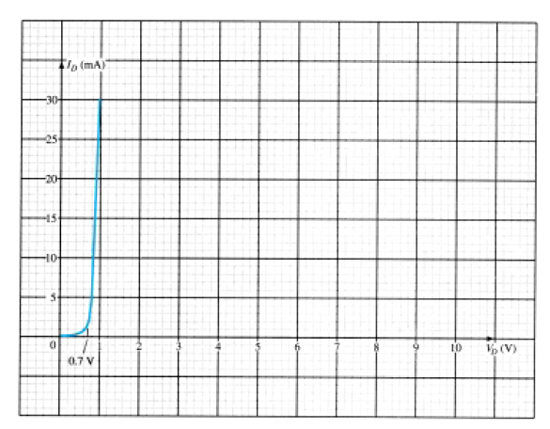

**SOLUTION:**

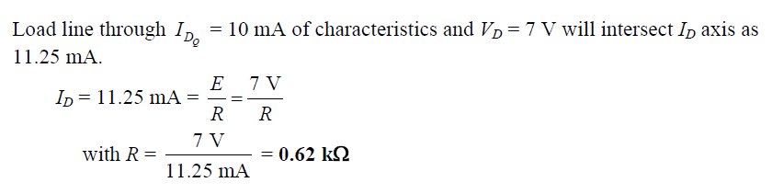

1. **Half Wave Rectifier Circuit- with I-V characteristics**

* Complexity Level : NORMAL
* Textbook Name : Electronic Devices and circuit Theory, 7th Edition, PHI
* Author Name : Robert Boylestad
* Page Number : 103 (Tutorial Problem) Qn. 4

(a) Using the approximate characteristics for the Si diode, determine the level of VD, ID, and VR for the circuit of Fig. 2.133.

(b) Perform the same analysis as part (a) using the ideal model for the diode.

(c) Do the results obtained in parts (a) and (b) suggest that the ideal model can provide a good approximation for the actual response under some conditions?



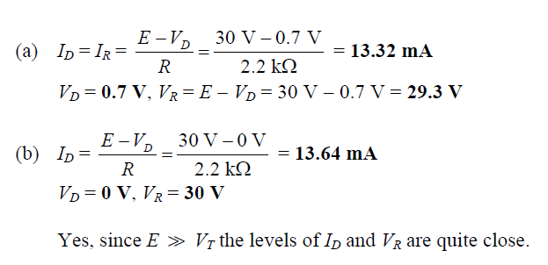**SOLUTION:**

1. **Half Wave Rectifier Circuit:(Diode reverse connected)**

* Complexity Level : HIGH
* Textbook Name : Electronic Devices and circuit Theory, 7th Edition, PHI
* Author Name : Robert Boylestad
* Page Number : Solved Example Pg.71

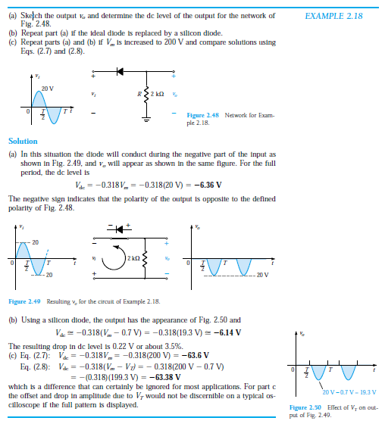

**Tutorial problem**

1. **Full Wave Rectifier Circuit:(2 diodes replaced with resistors)**

* Complexity Level : HIGH
* Textbook Name : Electronic Devices and circuit Theory, 7th Edition, PHI
* Author Name : Robert Boylestad
* Page Number : Pg. 75

